**Project Report**

**Submitted in fulfilment of the training of**

**OOPS with JAVA**

**By**

**Akash Singh (11900122038)**

**Abhinay Giri (11900122030)**

**Aviraj Roy (11900122047)**

**Second year student of**

**Siliguri Institute of Technology**





**Under the supervision of**

Mr. Vishal Ray

**Sikharthy Infotech Pvt. Ltd.**

**Department of Computer Science Engineering**

Date: 15/12/2023

I hereby forward the documentation prepared by us **Akash Singh, Abhinay Giri & Aviraj Roy** under the supervision of Mr. Vishal Ray Sir entitled **Library Management System** accepted as fulfilment of the requirement for the Training in **OOPs in JAVA** from **Siliguri Institute of Technology** affiliated to **Maulana Abul Kalam Azad University of Technology** (**MAKAUT**).

|  |  |
| --- | --- |
| ______________________________    **Mr. Vishal Ray**  **(Senior Software Engineer & Project Manager)**    **Project Guide**  **Sikharthy Infotech Pvt. Ltd.** | ____________________________________    **Akash Singh**  **Abhinay Giri**  **Aviraj Roy**  **Department of Computer Science Engineering**  **Siliguri Institute of Technology** |

**Library Management System**

By

**Akash Singh (11900122038)**

**Abhinay Giri (11900122030)**

**Aviraj Roy (11900122047)**

UNDER THE GUIDANCE OF

**Mr. Vishal Ray**

**Project Guide**

**Sikharthy Infotech Pvt. Ltd.**

THEIS SUBMITTED IN FULFILLMENT OF THE REQUIREMENTS FOR THE TRAINING OF

**OOPS in JAVA**

IN

COMPUTER SCIENCE ENGINEERING

**SILIGURI INSTITUTE OF TECHNOLOGY**

**AFFILIATED TO**

**Maulana Abul Kalam Azad University of Technology**

[**Address**](https://www.google.co.in/search?rlz=1C1GTPM_enIN734IN734&biw=1366&bih=613&q=future+institute+of+technology+address&stick=H4sIAAAAAAAAAOPgE-LVT9c3NEyrMC-JTzbO0JLNTrbSz8lPTizJzM-DM6wSU1KKUouLAYQ6jCEwAAAA&sa=X&ved=0ahUKEwi3htjS0_rbAhVLQY8KHTJnC-kQ6BMI1wEwEQ)**:**Hill Cart Road, Salbari, Sukna, West Bengal 734009

[**Phone**](https://www.google.co.in/search?rlz=1C1GTPM_enIN734IN734&biw=1366&bih=613&q=future+institute+of+technology+phone&sa=X&ved=0ahUKEwi3htjS0_rbAhVLQY8KHTJnC-kQ6BMI6gEwEw)**:**094345 27272

**Email:**

**Website**: http://www.sit.techno.org/

**Certificate of Approval**

The foregoing project is hereby approved as a creditable study for the B.Tech in Computer Science Engineering and presented in a manner of satisfactory to warrant its acceptance as a prerequisite to the degree for which it has been submitted. It is understood that by this approval the undersigned do not necessarily endorse or approved any statement made, opinion express or conclusion therein but approve this project only for the purpose for which it is submitted.

Final Examination for

Evaluation of the Project ----------------------------------------

-----------------------------------------

------------------------------------------

Signatures of Examiners

**ABSTRACT**

The "Library Management System in JAVA" project aims to develop a user-friendly, modular, and efficient software solution for managing library resources. Using Java, the system focuses on book cataloging, member management, and streamlined borrowing/returning processes. The project features a secure admin panel for CRUD operations on books. With an emphasis on simplicity and scalability, the system enhances library operations while serving as a Java programming learning resource.

**ACKNOWLEDGEMENT**

It is a great pleasure for me to acknowledge the assistance and participation of a large number of individuals to this attempt. Our project report has been structured under the valued suggestion, support and guidance of **Mr. Vishal Ray**. Under his guidance we have accomplished the challenging task in a very short time.

Finally, we express our sincere thankfulness to our family members for inspiring me all throughout and always encouraging us.

**Akash Singh**

**Abhinay Giri**

**Aviraj Roy**

**Department of Computer Science Engineering**

**TABLE OF CONTENTS**

Chapter 1: Introduction

1: Introduction

Chapter 2: What We Used

2.1: JAVA

2.2: IDE

Chapter 3: Functionality of the Website

3.1: User Login Page

3.2: Book Management

3.3: Student Management

3.4: Book Borrowing & Returning

3.5: User Dashboard

Chapter 4: FEATURES

4.1: Librarian Features

4.2: Student Features

Chapter 5: System Analysis

5.1: Identification of the need

5.2: Preliminary Investigation

5.3: Feasibility Study

Chapter 6: Project Planning and Scheduling

Chapter 7: Functional Requirement of the System

7.1: Hardware Requirement

7.2: Software Specifications

Chapter 8: Conclusion

Chapter 9: References

**1. Introduction**

The Library Management System is a Java-based application designed to automate and enhance the management of library resources. The system includes features for adding and viewing books, managing student information, and facilitating book borrowing and returning processes. The subsequent sections of this document will delve into the specific requirements and functionalities of the system.

**2. What We Used**

**2.1 Java**

The Library Management System is developed using Java as the primary programming language. The system utilizes Java version "21.0.1," released on October 17, 2023, which is classified as a Long-Term Support (LTS) version. The Java SE Runtime Environment (JRE) version "21.0.1+12-LTS-29" is employed for executing Java applications. Additionally, the system runs on the Java HotSpot 64-Bit Server Virtual Machine, providing efficient performance in mixed mode.

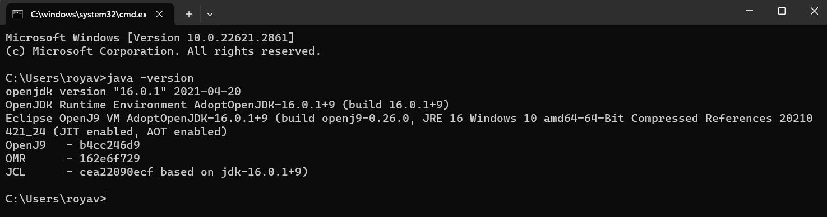

**2.2 Integrated Development Environment (IDE)**

The development environment for the project is Visual Studio Code (VS Code). VS Code is a lightweight yet powerful source code editor, providing features such as syntax highlighting, debugging support, and version control integration. Its simplicity and extensibility make it an ideal choice for Java development in this project.

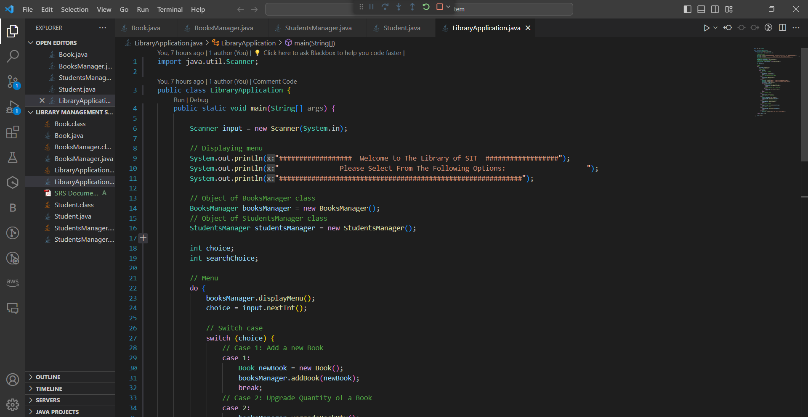

**3. Functionality of the Library Management System**

**3.1 User Login Page**

The Library Management System features a secure user login page to ensure access control. Librarian authentication is managed through a username and password mechanism, providing a secure gateway to the system's administrative functionalities.

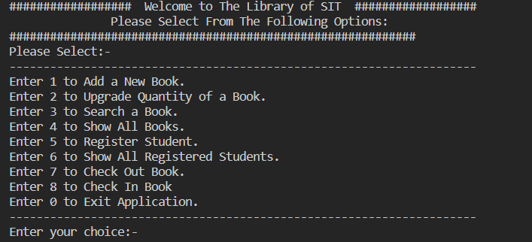

**3.2 Book Management**

**3.2.1 Add Book**

Librarians can add new books to the system, providing details such as title, author name, category, and quantity. The system checks for existing books and allows librarians to update the quantity if the book is already in the inventory.

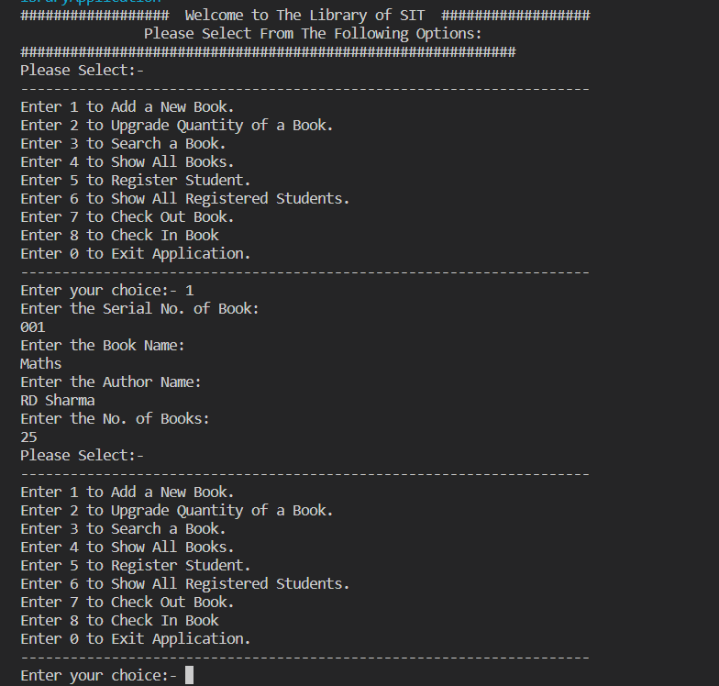

**3.2.3 View Book Inventory**

Librarians have the ability to view the entire book inventory, including details such as title, author name, category, and available quantity. This feature assists in maintaining an organized and up-to-date catalog of library resources.

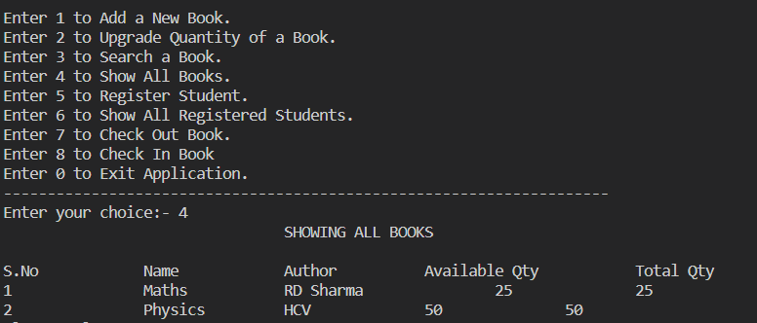

**3.2.4 Search Book**

The system allows users to search for books based on various criteria, including title, author name, and category. The search functionality provides quick and efficient access to specific books within the inventory.

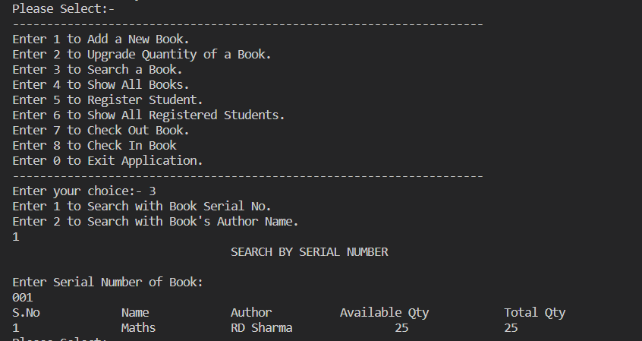

**3.3 Student Management**

**3.3.1 Add Student**

Librarians can add new students to the system by entering their ID, name, and mobile number. This feature ensures accurate tracking of student information for book borrowing and returning processes.

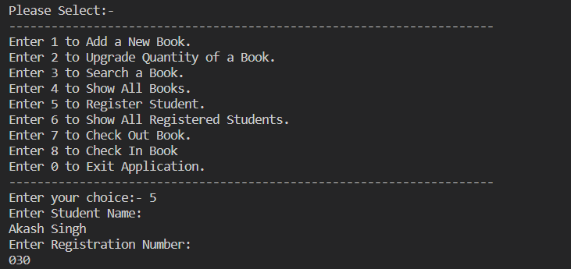

**3.3.3 View Student Database**

Librarians have the ability to view the student database, displaying essential details such as student ID, name, and mobile number. This functionality aids librarians in managing student records effectively.

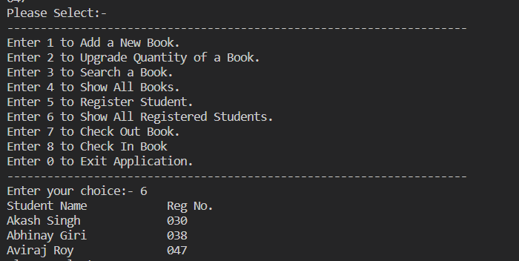

**3.4 Book Borrowing and Returning**

**3.4.1 Check Out**

Students can check out books by providing their ID and the title of the desired book. The system checks for the availability of the book and updates the inventory and student's borrowed books accordingly.

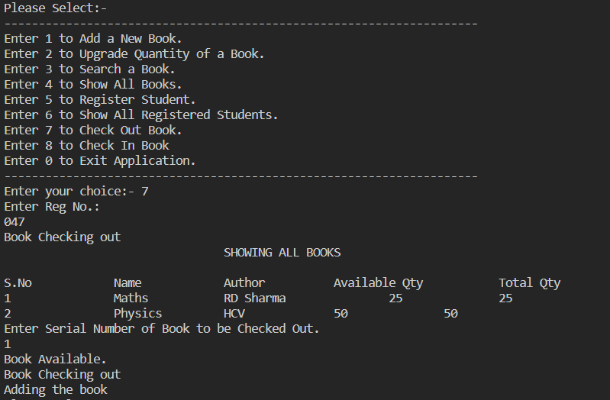

**3.4.2 Check In**

Students can return books by providing their ID and the title of the book being returned. The system updates the book inventory and removes the book from the student's borrowed list.

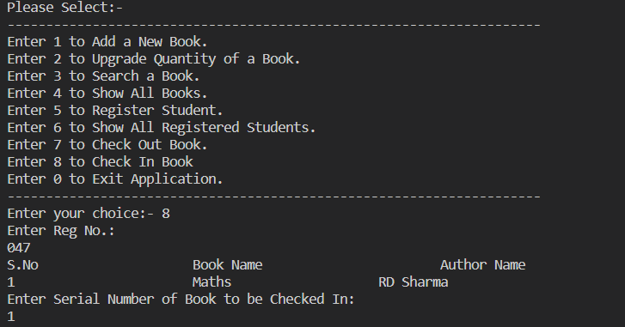

**3.5 User Dashboard**

Authenticated users (librarians) are presented with a user-friendly dashboard summarizing key metrics such as the total number of books, available books, total students, and any relevant notifications.

**4. Features**

**4.1 Librarian Features**

**4.1.1 Secure Login**

Librarians can securely log in to the system using a username and password.

**4.1.2 Book Management**

**Add Book:**

Librarians can add new books to the inventory, specifying details such as title, author name, category, and quantity.

**View Book Inventory:**

Librarians can view the complete book inventory, including details such as title, author name, category, and available quantity.

**Search Book:**

Librarians can search for books based on criteria such as title, author name, and category.

**Delete Book:**

Librarians can remove a book from the inventory, ensuring accurate maintenance of the library catalog.

**4.1.3 Student Management**

**Add Student:**

Librarians can add new students to the system by providing their ID, name, and mobile number.

**View Student Database:**

Librarians can view the complete student database, including details such as student ID, name, and mobile number.

**Delete Student:**

Librarians can remove a student from the system, ensuring accurate maintenance of the student database.

**4.1.4 Book Borrowing and Returning**

**Check Out:**

Librarians can facilitate the book check-out process for students, updating the book inventory and student records.

**Check In:**

Librarians can process book returns, updating the book inventory and removing the book from the student's borrowed list.

**4.1.5 Dashboard**

**User Dashboard:**

Librarians are presented with a dashboard summarizing key metrics such as the total number of books, available books, total students, and relevant notifications.

**4.2 Student Features**

**4.2.1 Book Search**

Students can search for books in the library inventory based on criteria such as title, author name, and category.

**4.2.2 Book Borrowing and Returning**

**Check Out:**

Students can check out books by providing their ID and the title of the desired book.

**Check In:**

Students can return books by providing their ID and the title of the book being returned.

**4.2.3 User Dashboard**

**Student Dashboard:**

Students have access to a dashboard displaying their borrowed books and any relevant notifications.

**5.1 Identification of Need**

**5.1.1 Background**

The foundation of any successful project lies in meticulous planning and the precise execution of those plans. This principle guided the development of the Library Management System, recognizing that a well-thought-out plan and its effective execution are key to success. The primary need addressed by the system is to simplify user access to library resources, enhancing the management and retrieval of information.

**5.1.2 Objectives**

Efficient Resource Management: Automate book cataloging and student tracking for efficient library resource management.

User-Friendly Access: Provide a user-friendly interface for both librarians and students to access and manage library resources.

Error Reduction: Minimize errors associated with manual book and student information management.

**5.2 Preliminary Investigation**

**5.2.1 Current System Overview**

The existing library management system relies on manual processes for cataloging and tracking, leading to inefficiencies and errors. The need for a more streamlined and automated system is evident.

**5.2.2 Stakeholders**

Librarians: Responsible for managing library resources and student information.

Students: Utilize library services for borrowing and returning books.

**5.2.3 Identified Problems**

Manual Cataloging: Time-consuming manual cataloging of books and student information.

Error-Prone Processes: Increased likelihood of errors in book and student information.

Limited Accessibility: Challenges in quick and efficient retrieval of information.

**5.3 Feasibility Study**

**5.3.1 Economic Feasibility**

Cost-Benefit Analysis: The cost of system development is justified by the long-term benefits of increased efficiency and reduced errors.

Return on Investment: The system is expected to yield a positive return on investment through improved library management.

**5.3.2 Technical Feasibility**

Java Technology: The choice of Java ensures cross-platform compatibility and robust system performance.

Database: MySQL provides a reliable and scalable database solution for storing book and student information.

**5.3.3 Operational Feasibility**

User Training: Librarians and students will receive training to ensure a smooth transition to the new system.

Integration: The system will integrate seamlessly into existing library operations without disrupting daily activities.

**6. Project Planning and Scheduling**

Scheduling is an important activity of any project management. Scheduling a software project involves first breaking down an entire problem into a logical set of tasks which would be assigned to developers.

In order to Schedule the “**LIBRARY MANAGEMENT SYSTEM**” we have to do the following:

▪ Identify the tasks needed to complete the project.

▪ Determine the dependency among different tasks.

▪ Establish the most likely estimates for the duration of the identified tasks.

▪ Plan the starting and ending dates for various tasks.

▪ Determine the critical path i.e. the chain of tasks that determine the duration of the project.

**7. Functional Requirement of the System**

The Library Management System is a comprehensive solution implemented in Java to cater to the specific needs of librarians and students within a local library setting. Unlike web-based systems, this application is designed for offline use, focusing on optimizing resource management, book transactions, and student-related functions.

The subsequent sections elaborate on the functional requirements, delineating the expected behaviors, user interactions, and the overall architecture crucial for the seamless operation of the Library Management System within a standalone environment.

**7.1 HARDWARE REQUIREMENTS**

The minimum Hardware requirements for the application to run smoothly should have the following configuration:

|  |  |
| --- | --- |
| **Processor** | Intel Core i3 |
| **RAM** | 4GB or more |
| **HDD** | 3GB or more |

**7.2 SOFTWARE SPECIFICATIONS**

The minimum software requirements are as follows:

|  |  |
| --- | --- |
| **Operating System** | Windows 7,8 and upwards |
| **Language Used** | Java Language |
| **Working IDE** | Visual Studio Code, Eclipse |

**8. CONCLUSION**

The Library Management System is a Java-based project that efficiently manages book inventory, student information, and transactions. It includes features such as adding/deleting books, viewing inventory, searching books, and managing student records. The system undergoes systematic analysis, feasibility studies, and follows functional requirements. Hardware requirements include an Intel Core i3 processor, 4GB+ RAM, and 3GB+ HDD. Software specifications involve Windows OS, MySQL database, Java language, and Visual Studio Code or Eclipse as the IDE. The data dictionary provides logical characteristics of data stores, facilitating system analysis and error detection. Overall, the system offers a user-friendly interface for effective library resource management.

**9. REFERENCES**

1. <https://www.javatpoint.com/>
2. https://www.freecodecamp.org/
3. Programming With Java by E Balaguruswamy.
4. https://www.w3schools.com/